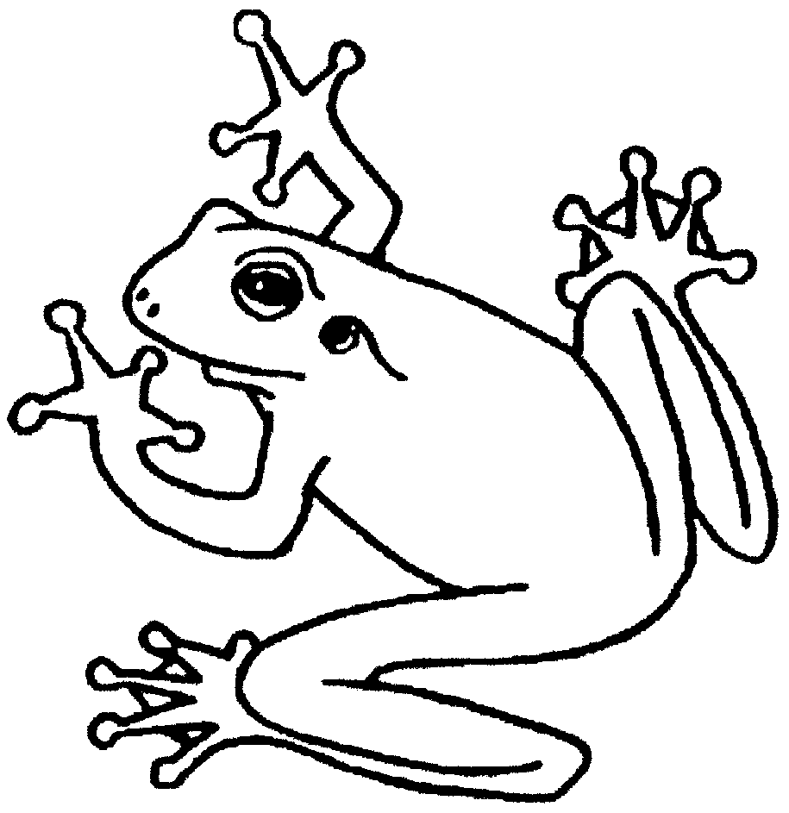

BRITISH HERPETOLOGICAL SOCIETY AND THAMES & CHILTERN HERPETOLOGICAL GROUP

Joint meeting Sunday 8th September 2019, 2.30 – 7.00 pm at the Drake Hall, Amersham Community Centre, Chiltern Ave, Amersham, Bucks, HP6 5AH.
2.30 – 3.00 Arrival and coffee/refreshments
3.00-5.30 Invited Speakers:

Chairman: Simon Townson

3.00 – 3.30. Matthew Rendle, Soham Mukherjee, Brinky Desai (Wildlife Vets International): ‘Conservation Management of the Indian Python (Python molurus molurus) in Gujarat, India’

3.30 – 4.00. Louise Masters (Durrell Institute for Conservation and Ecology, University of Kent): ‘Movement Patterns and Refuge Use by Slow Worms’

Short break and refreshments/informal session (see below)

Chairman: Colin Melsom

4.30 – 5.00. Karen Haysom (Amphibian and Reptile Conservation Trust): ‘The UK Pool Frog (Pelophylax lessonae) Re-Introduction Project: Head-Starting and Release of Tadpoles in Norfolk’

5.00 – 5.30. George Lonsdale (Centre for Applied Zoology, Cornwall College Newquay): ‘Snakes in the Clouds: Assessing the Cloud Forest Snake Community of Cusuco National Park, Honduras’

5.30 -6.30. Further refreshments and an Open and Informal Session for members – Exhibition of captive bred animals, plants, insects and items/posters of herpetological interest (including science, books, art, photography). There will be limited space for up to 20 exhibits. Members who would like space should contact Simon Townson (0770 775 1900 or s.townson@imperial.ac.uk), or Colin Melsom (07852 949405 or colinmelsom@sky.com)

Amersham is easy to get to via J18 of the M25 or by tube/rail to Amersham station. Parking and entrance to the meeting are free.

