

**HERPETOFAUNA OF SURREY**

**Date: Sunday 1st May 2016**

***Please note that due to limited numbers this event is open to BHS members only***

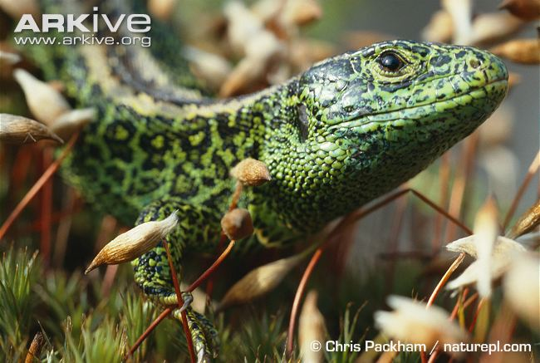

Cost: £15 registration fee

***Provisional itinerary***

* Meet at 9am at the Witley Centre, Witley, Godalming, Surrey GU8 5QA from where we will proceed to several reptile reserves which support populations of sand lizards, smooth snakes, adders, slow worms, common lizards and grass snakes. Hopefully we will be able to see all six species of UK reptiles and natterjack toads.

After the field trip we will proceed to a local hostelry for an evening meal (optional)

Field visits will be led by Rob Free (ARC Weald Reserves Manager) and Jan Clemons (BHS). Maps & postcodes will be sent to all attendees prior to the field visit.



**HERPETOFAUNA OF SURREY**

**Sunday 1st May 2016**

**BOOKING FORM**

I wish to book……….place(s) on the 2016 Field visit to Surrey on 1st May 2016 @ £15/person

I enclose a cheque for £…………. made payable to ‘The British Herpetological Society’.

Signed ……………………………………………… Date ………………………….

**Please return this form and full payment to**: Jan Clemons, 8, Carthusian Road, Coventry CV3 6HA by **15th April 2016** at the latest.

For further information please ring 07720 814414 or email janclemons2015@gmail.com

**Advice for members**

* Participants must take out their ***own personal & belongings insurance***. The Society cannot accept any liability with regards to personal injury or loss or damage to belongings.
* Reptile sightings cannot be guaranteed, especially in the event of bad weather. Alternatives will be arranged where possible but please plan to bring waterproof boots and clothing together with a packed lunch

Name…………………………………………….Daytime Tel. ………………………….. Mobile …………………………

Address …………………………………………………………………………

Postcode ……………………

Email……………………………………………………..

BHS membership number ………………..