HERPETOFAUNA OF JERSEY

Dates: 3rd – 5th May 2014

INCLUDEPICTURE "http://groups.arguk.org/images/comprofiler/plug_profilegallery/70/tnpg_1945919240.jpg" \* MERGEFORMATINET INCLUDEPICTURE "http://groups.arguk.org/images/comprofiler/plug_profilegallery/70/tnpg_1945919240.jpg" \* MERGEFORMATINET 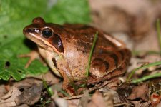 | INCLUDEPICTURE "http://groups.arguk.org/images/comprofiler/plug_profilegallery/70/tnpg_1645469518.jpg" \* MERGEFORMATINET INCLUDEPICTURE "http://groups.arguk.org/images/comprofiler/plug_profilegallery/70/tnpg_1645469518.jpg" \* MERGEFORMATINET 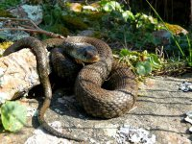 | INCLUDEPICTURE "http://groups.arguk.org/images/comprofiler/plug_profilegallery/70/tnpg_1296717690.jpg" \* MERGEFORMATINET 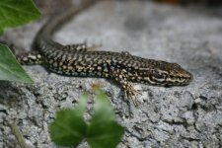
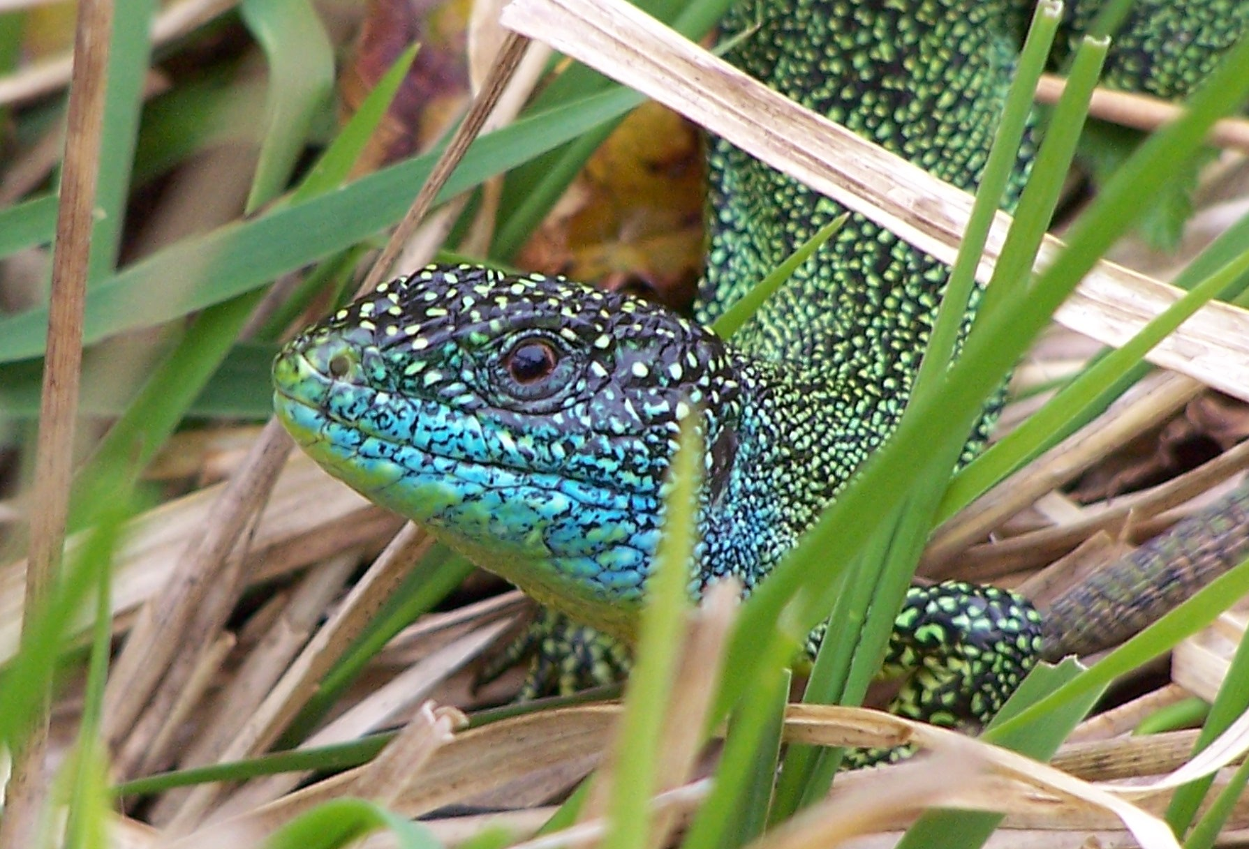 | INCLUDEPICTURE "http://groups.arguk.org/images/comprofiler/plug_profilegallery/70/tnpg_2133991247.jpg" \* MERGEFORMATINET 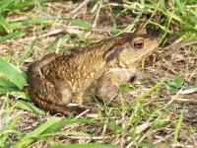 | 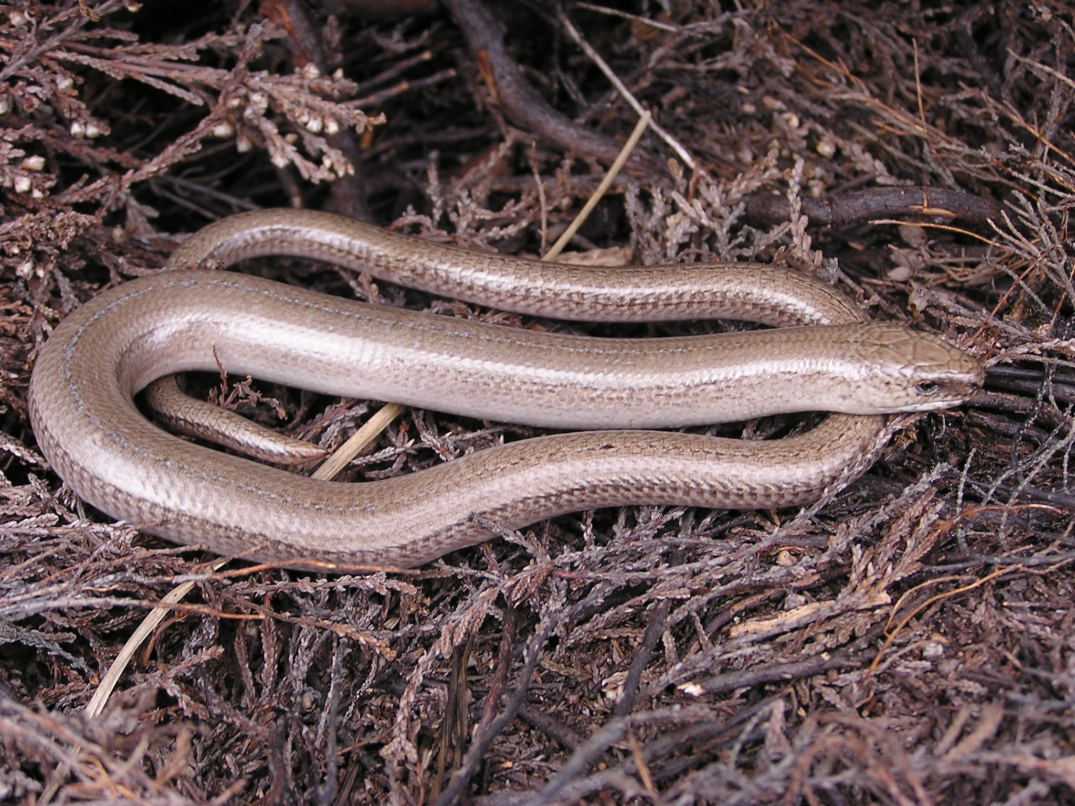

All photographs courtesy of Jersey Amphibian & Reptile Group http://groups.arguk.org/jarg/ and Amphibian and Reptile Conservation http://www.arc-trust.org

Please note that due to limited numbers this event is open to BHS members only

Cost: £60 registration fee including minibus transport
(Travel to and from Jersey, accommodation (see option below), meals and entry fees to Jersey Zoo and Gorey Castle at own cost.)

Provisional itinerary
Day 1: Meet at Jersey Airport c. 2.00pm. Key sites on west coast (Ouaisne, Les Landes, Creepy Valley)

Day 2: am -The Jersey grass snake project. pm - Tour of Jersey Zoo with Matt Goetz, Head of Herpetology

Day 3: am - key sites on east coast (Gorey Castle). pm - at leisure and return home

Field visits will be led by John Wilkinson (BHS) and Nina Cornish (Jersey ARG)

Accommodation Option
The BHS have provisionally booked bed & breakfast accommodation (£55/person/night) at Maison Gorey www.maisongorey.com
Alternatively there is a list of a range of accommodation in Jersey from 5* hotels to camp sites. Go to http://jersey.com/English/accommodation

HERPETOFAUNA OF JERSEY BOOKING FORM

I wish to book……….place(s) on the 2014 Field visit to Jersey @ £60/person

I wish to book 2 days accommodation at Maison Gorey @ £110/person/room or £55/person/ twin room (shared)

I enclose a cheque for £…………. made payable to ‘The British Herpetological Society’.

Signed ……………………………………………… Date ………………………….

Please return this form and full payment to: Jan Clemons, 8, Carthusian Road, Coventry CV3 6HA by 31st March 2014 at the latest.
For further information please ring 07720 814414 or email clemonsj@btinternet.com

Advice for members
- Participants must take out their own personal & belongings insurance. The Society cannot accept any liability with regards to personal injury or loss or damage to belongings.
- Reptile sightings cannot be guaranteed, especially in the event of bad weather. Alternatives will be arranged where possible but please plan to bring waterproof boots and clothing.

Name………………………………. Daytime Tel. ………………………….. Mobile …………………………

Address …………………………………………………………………………

Postcode ……………………

Email……………………………………………………..

Special Dietary requirements/needs, etc……………

BHS membership number ………………..

